DEPARTMENT OF COMPUTER SCIENCE AND APPLICATIONS

PANJAB UNIVERSITY CHANDIGARH



**C++ project On**

**“Hostel Management System”**

**SUBMITTED TO: SUBMITTED BY:**

**Dr. Sonal Chawla RINKI**

**MCA –1(Morning) Roll No - 33**

**CERTIFICATE**

This is to certify that **Rinki (Roll no. 33),** student of MCA-1 (Morning) has successfully completed his project **“Hostel Management System”** under my guidance positively. The project progress has been continuously reported and has been in my knowledge consistently. The project is the original work done by the mentioned student only.

**Date: Project Guide:**

Dr. Sonal Chawla

**ACKNOWLEDGEMENT**

A formal statement of acknowledgment is hardly sufficient to express our gratitude towards the personalities who have helped us to undertake and carry out this project. I hereby convey our thankfulness and obligation to my parents, friends, and my professor who provided valuable help, support, and guidance to carry on this project. I take this opportunity to express my deepest gratitude to those who have generously helped me by providing valuable knowledge and expertise during my Project.

I am thankful to **Dr. Sonal Chawla** Professor of Department of Computer Science and Applications (DCSA), Panjab University, Chandigarh, for her thorough guidance right from the first day till the end of the project and for giving me the required guidance and for removing any difficulties faced by me during the project.

I would like to thank every person who has contributed in any of the ways in my training. I thank the almighty God for blessing me with new challenges in life and giving me enough strength to meet those challenges.

Table of Contents

PROJECT TITLE 5

AIM AND PROJECT DETAILS (OBJECTIVES) 7

METHODOLOGY FOLLOWED 9

Feasibility study 9

Design phase and DFD 10

Hardware and Software specification: 13

IMPLEMENTATION 14

TESTING WITH VALIDATIONS 37

SIGNIFICANCE OF THE PROJECT 40

To society 40

To IT community 40

To Education and Research 41

BIBLIOGRAPHY/ REFERENCES 42

# PROJECT TITLE

**(Hostel Management System)**

To begin with, let us first understand the importance of the project title. It is dictum technically that more the users of the application, the more successful the application is. **“Project Title”** - is the most eye-catching aspect of any project. The project title should be attractive enough will bring user’s/customer’s attention. As a result, they will go through the description of the Project at least once. So, while giving the project a title, a few things should be kept in mind which are as follows:-

* The title of the project should be small and concise.
* The title name should depict the project’s purpose.
* The name should be attractive enough to steal the limelight over other similar projects.

So keeping these things in mind, I have named my project **“Hostel Management System”**. Well, the aim of the project will be discussed in the next section, after which this title will make even more sense. The output screen (prepared using graphics) mentioning the title of the project is:

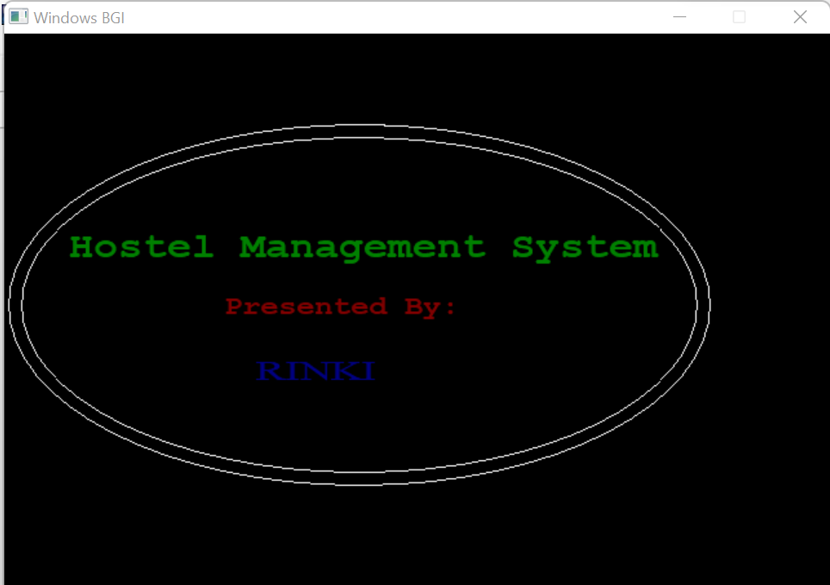

Now the name “Hostel Management System” has been used as a project title, which can be used by the hostel to maintain the record of students and the rooms. To make it more realistic I have assigned a particular hostel name that will use this project to record the details of students. The hostel name, which I used, is **“Girls Hostel No 1”.** So the overall motive to use a hostel name like this is to make the project more realistic and interesting. The output screen was prepared using graphics.

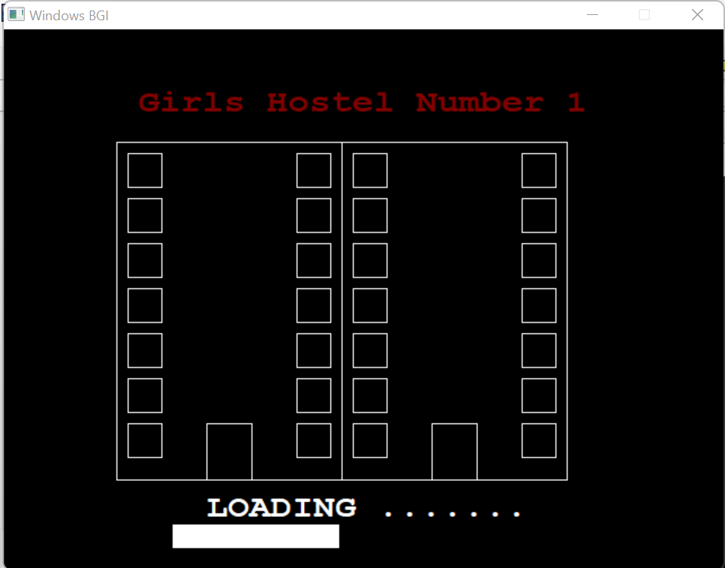

**AIM AND PROJECT DETAILS (OBJECTIVES)**

**AIM:**

Any project without aim would be like “a ship without a captain”. It is the AIM that gives the project life. So a project needs to have some aim and the project should be developed in accordance to serve the aim. The project “Hostel Management System” has been developed by keeping various aims in mind. Some of these aims are:-

* To design an online hostel management system where each user’s activity is in a computerized way rather than the usual manual process which appears to be time-consuming.
* To upgrade the hostel booking system from manual handbook registration to online registration.
* To record every detail of the student and the rooms

## **PROJECT DETAILS AND OBJECTIVES:**

Now let us start with the detailed description (detailing) of the project. My project “Hostel Management System” has a lot of key features which eventually contribute to enhancing the popularity of the project. Some of the key features are discussed as follows:

* The C++ graphics have been used appropriately to make the project user-friendly and attractive.
* All the validations have been implemented to ensure the correctness of the data supplied.
* As far as technicalities are concerned, the code has been properly commented on so that the code is readable.
* The project has been developed by taking care of the time complexity of the project so that the results are faster.
* File manipulations have been used to store the data permanently and manipulate that data later on.
* Along with these features, there are some **objectives** of the projective. These objectives are a must to achieve the proper and efficient functioning of the project.

All these **objectives** have been achieved in this project. Some of these **objectives**

are as follows:

* + To create a new student record with correct personal details.
  + To view all details related to a particular student as well as the room.
  + Indicate the room availability and the location of the rooms
  + To modify and delete any student record with ease.
  + To store and retrieve correct data from input and output sources.
  + To maintain privacy using admin privileged passwords.

# METHODOLOGY FOLLOWED

Whenever a project needs to be started, a proper roadmap is to be followed. It is the best way to follow step by step procedure to achieve any goal. The procedure which is followed to develop any software is called **SDLC (System Development Life Cycle)**. This SDLC includes steps that are to be followed sequentially. In this project, the SDLC steps have been followed. The important steps and the way they have been followed in this project is as follows:

## **Feasibility study:**

After identification of requirements, an initial investigation in a proposal that determines whether an alternative system is feasible or not. A proposal summarizing the thinking of the analyst is presented to the user for review. When approved, the proposal initiates feasibility study that describes and evaluates candidate systems and provides for the selection of best system that meets system performance requirements. Feasibility study involves following considerations:

1. **Operational Feasibility** is the measure of how well a proposed system solves the problem, and take advantage of the opportunities identified during scope definition.
2. **Economic Feasibility** determines whether the application to be developed will be within the budget and would also provide Return On Investment (ROI) or not.
3. **Technical Feasibility** is an evaluation of hardware and software and how it meets the need of the proposed system. It ensures that the current available resources would meet the basic requirement of application.
4. **Time Feasibility** is determining that whether the project would be developed within the given deadline or not. This would ensure the main aspect of the project i.e. customer satisfaction.

All these feasibility considerations were taken care of, while developing this project. Before actual implementation of the project, these four feasibility considerations were considered in “Hostel Management System” using following procedures.

* The operational feasibility was checked by using Research and Development also called **R&D**. All the important inbuilt functions and required functionalities were examined in accordance with the desired output and the offered benefits.
* The economic feasibility was not much of a concern as far as this project is concerned. There was no as such big requirement of money in terms of investment and moreover the project would definitely yield propitious outputs.
* The project was considered technically feasible, as the hardware and software required for this project is very basic. The hardware of a normal PC or laptop would be enough to support this project. The software used to run the project is also open source makes it technically feasible.
* Well, the big challenge of this project was time limit. So time was a big concern. But when it was analysed, the proper planning and working hours were prepared, which eventually resulted in time feasibility of the project.

## **Design phase and DFD:**

Based on user needs and detailed analysis of the system a software must be designed. It is the most crucial phase in the development of a system. In this phase, the process continues to move from what question to howquestion. The logical design is turned into a physical design. The major tools and techniques used for describing the system design of the system are: Flowcharts, Data Flow Diagram (DFD), Data Dictionary, Structured English, Decision Table and Decision Tree.

Wireframes are main part of the design phase. Because before the actual implementation of the project, the blueprints are to be prepared so that the customer satisfaction can be achieved in accord with their requirement. So the number of screens and the task of each screen were wire-framed so as to ease the task of actual implementation.

Now coming to the tools used for design phase. As discussed earlier, there are many tools which are used to design a project. I have used the most common and probably the most beneficial tool called **DFD.** Data flow diagrams are used to graphically represent the flow of data in an information system. DFD describes the processes that are involved in a system to transfer data from the input to the file storage and reports generation.

To represent different entities, operations, objects there are various **symbols** used. These symbols are standard and thus standardise the Data Flow Diagram. These **DFD symbols** make it easy to distinguish between different parameters of the object. So, understanding the importance of symbols, let us start with the various symbols used to design Data Flow Diagram (DFD).

|  |  |
| --- | --- |
| or | PROCESS |
|  | DATA STORE |
|  | EXTERNAL ENTITIES |
|  | DATA FLOW |

Data flow diagrams are also categorized by **levels**. Starting with the most basic, level 0, DFDs get increasingly complex as the level increases. As you build your own data flow diagram, you will need to decide which level of details your diagram will be following.

**Level 0 DFDs**, also known as context diagrams, are the most basic data flow diagrams. They provide a broad view that is easily digestible but offers little detail. Level 0 data flow diagrams show a single process node and its connections to external entities.

**Level 1 DFDs** are still a general overview, but they go into more detail than a context diagram. In a level 1 data flow diagram, the single process node from the context diagram is broken down into sub processes. As these processes are added, the diagram will need additional data flows and data stores to link them together.

**Level 2+ DFDs** simply break processes down into more detailed sub processes. In theory, DFDs could go beyond level 3, but they rarely do. Level 3 data flow diagrams are detailed enough that it doesn’t usually make sense to break them down further.

The DFD prepared during design phase of this project is as follows:

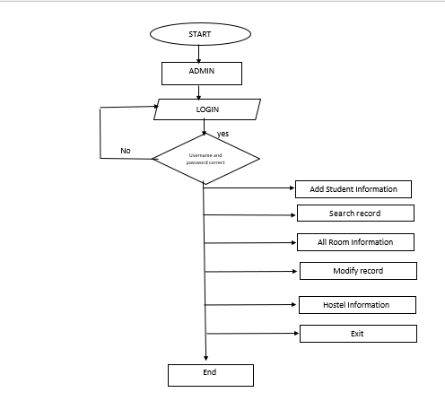

## **Hardware and Software specification:**

Computer hardware is the collection of physical elements that constitutes a computer system. Computer hardware refers to a physical parts and components of the computer such as monitor, mouse, keyboard, computer data storage, Hard Drive Disk (HDD), system unit (graphic cards, sound cards, memory, motherboard and chips), etc. that can be touched.

The minimum **Hardware** requirements for our program are as follows:

* PROCESSOR: Pentium IV processor or greater
* RAM: 128 Mega Byte (MB) or greater.
* HARD DISK: 1.2 Giga Byte (GB) or greater.
* Keyboard and mouse.
* MONITOR: colour (For best results)



Computer software, or just software is any set of machine readable instructions that directs a computer’s processor to perform specific operations. Computer hardware and software require each other and neither can be realistically used without the other.

The minimum **Software** requirements for our program are as follows:

* + OPERATING SYSTEM: Windows 2000 and later.
  + IDE USED: Turbo C++ or CodeBlocks or Dev C++.



# IMPLEMENTATION

# (INCLUDING CODE)

Now comes the actual implementation of the project. For the implementation the first step is to choose the IDE for building the project. Dev-C++has been used. Now the designing part is done. For the coding part, all the C++ Language concepts and IDE syntax should be clear. There are several **in built functions** in C++ that are invoked to use the functions that have already been developed with the best possible algorithms. The major advantages of these in built functions are that their time complexity is less, they can be called anywhere in the program, they need not to be compiled again and again. Now, we know that in built functions are there in the language. But we still need to know what the **libraries** actually are. The built-in functions are stored in the libraries. So whenever you want to use any function then header file, where the function definition is stored, need to be included. A single library contains a group of functions and those functions are grouped together on the basis of their similar functionalities. Moreover, the name given to the library also demonstrate the type of functions saved in the library. For example, library iostream.h stands for input output stream and the functions defined in this libraries are cout (standard output) and cin (standard input). Similarly, math.h include all mathematical functions for example sin, cos, pow etc. In this project several libraries have been used. Some of these libraries along with their need to be included are discussed as follows:

1. **graphics.h:** This header file is used to use the graphics that serve various purposes. The functions for using various colours have been defined in this header file. Apart from that, the functions for changing the text style, drawing shapes such as rectangle, circles, lines etc. and time delay has also been defined in this library file.
2. **iostream.h:** This header file is used to take the input using cin function which takes its input from standard input device and to produce the output using cout function on standard output device. Keyboard is the standard input device and monitor is the standard output device.
3. **dos.h:** This header file is one of the most interesting file. It has many functions which enhance the capability of the program. In my project I have used this header file to use delay() function, which makes the screen to sleep for the specific time supplied as argument to this function.
4. **fstream.h:** The header file is the base of this project. This is used for file manipulation. There are various functions in this header file for the manipulation of the contents in the file. For example, open() function is used to open the file with specified name in specified mode. Function read() is used to read the content of the file whereas write() is used to write the content in the file.
5. **string.h:** This header file is used to manipulate strings in different ways. There are various functions that have been used in this project. Some of the crucial functions used are strlen() to get the length of string, strcmpi() to compare two strings, strcpy() to copy one string to another.
6. **iomanip.h:** This header file is refers to input output manipulation. There is a big set of functions available in this header file. In this project, this header file has been used to organise the output in meaningful way. The function used for that purpose is setw() which sets the width of a column according to the specified value in the argument.

## **CODE IN FORM OF SUBROUTINES:**

Now when all the investigation and designing have been done, now it is time for the actual implementation of the project. Coding is the program that is executed at the back end to produce the desired outputs. The syntax has been taken care of. Coding is something that requires logic. There can be different logics for a single program. So to understand one’s logic comments in the code plays a crucial role. Apart from that, proper indentation improves the readability of the code. Now the code (in form of subroutines) of “Hostel Management System” is as follows:

## **For password Validation**

void hostel:: login()

{

system(" COLOR 5f");

char UserName[30],Password[30],ch;int i=0;

cout<<endl<<endl;

cout<<endl<<endl<<endl<<endl<<endl<<endl<<"\t\t\t\t\tEnter UserName:\t";

cin>>UserName;

cout<<endl<<endl<<"\t\t\t\t\tEnter Password:\t ";

while(1)

{

ch = getch();

if(ch==13)// enter key

break;

if(ch==32||ch==9)

continue;

else if(ch==8) //8 is ascii of backspace

{

if(i>0)

{

i--;

cout<<"\b \b";

}

}

else

{

cout<<"*";

Password[i]=ch;

i++;

}

}

Password[i] = '\0';

if(strcmp(UserName,"admin")==0 && strcmp(Password,"password")==0)

{

system("cls");

}

else

{

system("cls");

cout<<"\t\t\tAccess Denied!!!\a";

login();

}

}

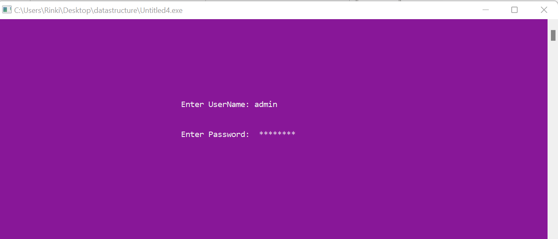

Now In the Dashboard of Hostel Management System, which has various options that perform specific operations. There will be 10 options, named:

1. Adding new student
2. Search Student Information
3. Display All room Information
4. Edit record
5. Rules and regulation
6. Quit

To execute all the operation we need one main menu and here is the code of the main menu in which we create the one object of class hostel.

int main()

{

hostel h;

h.login();

system("COLOR 6f");

int i;

cout << "\n\n\t\t\t";

for(i=0; i<59; i++)

{

cout << "*";

}

cout << "\n";

cout << "\t\t\t*\t\t\t\t\t\t\t *\n ";

cout << "\t\t\t*\t\t\tWELCOME to\t\t\t *\n";

cout << "\t\t\t*\t\tHostel Management System\t\t *\n";

cout << "\t\t\t*\t\t\t\t\t\t\t *\n";

cout << "\t\t\t";

for(i=0; i<59; i++)

{

cout << "*";

}

cout << "\n";

system("pause");

system("cls");

h.main_menu();

return 0;

}

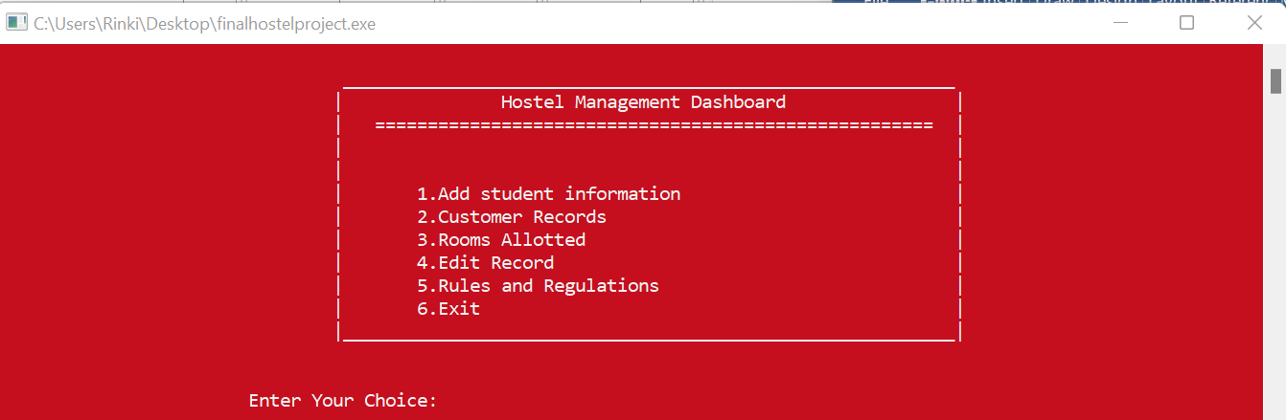

The operation to be performed is selected by entering the operation number to be performed. If valid operation number is entered then that particular operation number is performed. If operation number is invalid then it shows error. If we enter the operation number as 6 then it will quit the software.

Now that the options have been viewed, let us now go through the options one by one.

1. **Code for option 1**

void hostel::add()

{

system("cls");

system("COLOR 3f");

int r,flag;

ofstream fout("Record.dat",ios::app);

cout<<"\n\t\t\t\t\t Enter Student Detalis";

cout<<"\n\t\t\t\t\t **********************";

cout<<"\n\n\t\t\t\t\t Room no: ";

cin>>r;

flag=check(r);

if(flag)

cout<<"\n Room is not vaccant";

else

{

room_no=r;

cout << "\n\t\t\t\t\t Enter student name:\t ";

cin >> name;

cout<<"\n\t\t\t\t\t Address:\t\t ";

cin>>address;

again:

cout<<"\n\t\t\t\t\t Phone No:\t\t ";

cin>>phone;

if(strlen(phone)!=10)

{

cout<<"\n\t\t\t\t\t Requird 10 digits Phone Number:\n";

goto again;

}

cout<<"\n\t\t\t\t\t Dept Name:\t\t ";

cin>>dept;

again1:

cout<<"\n\t\t\t\t\t GENDER(M:male,F:female) : \t";

cin>>sex;

if((sex!='m')&&(sex!='M')&&(sex!='F')&&(sex!='f'))

{

cout<<"\t\t\t\t\tWrong Input ;Give correct data";

goto again1;

}

fout.write((char*)this,sizeof(*this));

cout<<"\n\t\t\t\t\t Welcom to Hostel Room no!!! "<<r;

}

cout<<"\n\n Press any key to continue!!";

system("pause");

fout.close();

}

Output of this screen is as follows:

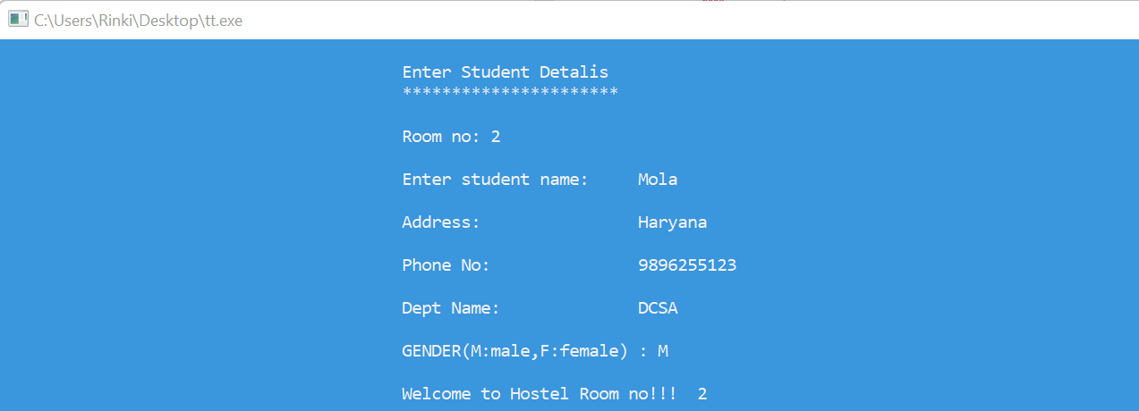

The output clearly shows how the date is read from the user. This data is further stored in file for later manipulations. The validations with data has been applied to maintain the correctness of the data.

Now the fourth option is update account which is further having 3 options:

* SEARCH BY NAME
* SEARCH BY ROOM NUMBER

Now proceeding further to the second option. The second option is searching the student record by room number or name. Searching by room number, it will show the summary of that particular room. Searching by Name ,it will show the information of that particular student. Let us view the code for this option

**2) CODE FOR OPTION 2**

void hostel::search()

{

system("COLOR 3f");

system("cls");

int choice,r;

cout<<"\n\t\t\t\t EDIT MENU";

cout<<"\n \t\t\t\t---------";

cout<<"\n\n\t\t\t\t 1.Serach By Name";

cout<<"\n\t\t\t\t 2.Search By Room No";

cout<<"\n\t\t\t\t Enter your choice: ";

cin>>choice;

switch(choice)

{

case 1: byname();

break;

case 2: byroom();

break;

default: cout<<"\n Wrong Choice.....!!";

}

cout<<"\n Press any key to continue....!!!";

getch();

} **Output of this shown is as follows:**

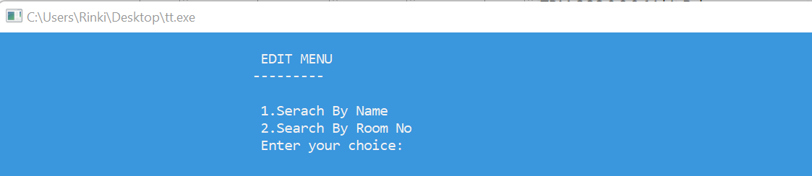

Option 4 has further 2 more option:

**Code for 4.1option**

{

system("cls");

system("COLOR 3f");

ifstream fin("Record.dat",ios::in);

int flag=0;

char sname[30];

cout<<"\n Enter name of a particular student for its details :- "<<endl;

cin>>sname;

while(!fin.eof())

{

fin.read((char*)this,sizeof(hostel));

int x;

x = strcmp(sname, name);

if(x==0)

{

system("cls");

cout<<"\n\t\t\t\t\t Student Details";

cout<<"\n\t\t\t\t\t ----------------";

cout<<"\n\t\t\t\t\t Room no: "<<room_no;

cout<<"\n\t\t\t\t\t Name: "<<name;

cout<<"\n\t\t\t\t\t Address: "<<address;

cout<<"\n\t\t\t\t\t Phone no: "<<phone;

cout<<"\n\t\t\t\t\t Department name: "<<dept;

cout<<"\n\t\t\t\t\t Gender: "<<sex;

flag=1;

break;

}

}

if(flag==0)

cout<<"\n"<<" NO student of this name is living in hostel"<<sname;

cout<<"\n\n Press any key to continue....!!";

getch();

fin.close();

}

**Output of this shown is as follows:**

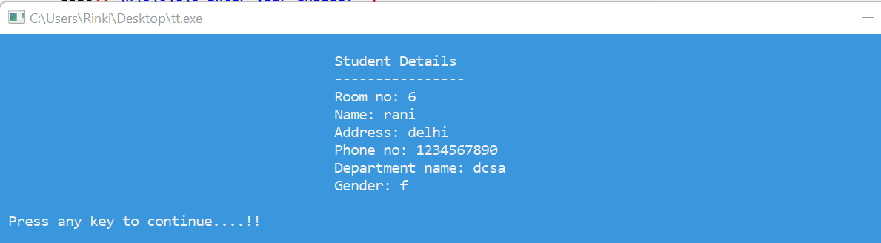

**Code for 4.2 option**

void hostel::byroom()

{

system("cls");

system("COLOR 3f");

ifstream fin("Record.dat",ios::in);

int r,flag=0;

cout<<"\n Enter room no. for a particular student's details :- "<<endl;

cin>>r;

while(!fin.eof())

{

fin.read((char*)this,sizeof(hostel));

if(room_no==r)

{

system("cls");

cout<<"\n\t\t\t\t\t Student Details";

cout<<"\n\t\t\t\t\t ----------------";

cout<<"\n\t\t\t\t\t Room no: "<<room_no;

cout<<"\n\t\t\t\t\t Name: "<<name;

cout<<"\n\t\t\t\t\t Address: "<<address;

cout<<"\n\t\t\t\t\t Phone no: "<<phone;

cout<<"\n\t\t\t\t\t Department name: "<<dept;

cout<<"\n\t\t\t\t\t Gender: "<<sex;

flag=1;

break;

}

}

if(flag==0)

cout<<"\n ROOM....!!"<<r<<" is free you can apply for that";

cout<<"\n\n Press any key to continue....!!";

getch();

fin.close();

}

**Output of this shown is as follows:**

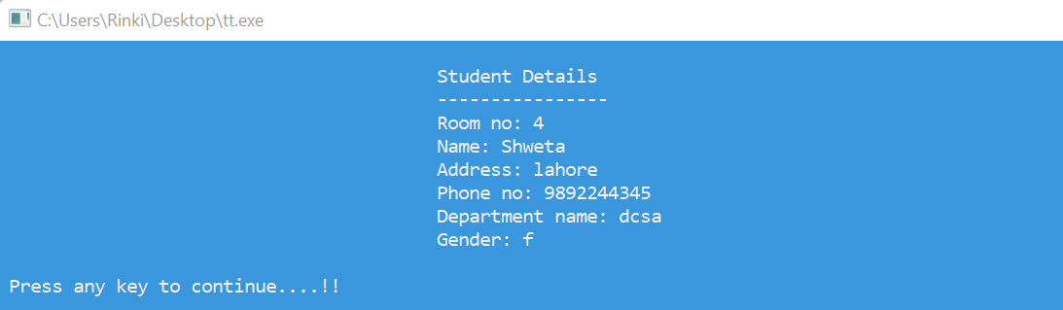

These outputs have been shown on the basis of room number.

Now proceeding further to the next option which it show the details of all room. For this option the room no number is needed from which the amount is to be withdrawn. Let us view the subroutine for this option.

1. **CODE FOR OPTION 3**

void hostel::rooms()

{

system("COLOR 3f");

system("cls");

ifstream fin("Record.dat",ios::in);

cout<<"\n\t\t\t List Of Rooms Allotted";

cout<<"\n\t\t\t ----------------------";

cout<<"\n\n Room No.\tName\t\tAddress\t\tPhone No.\tDepartment\t\tSex\n";

cout<<"----------\t--------\t----------\t--------\t------------\t\t-------";

while(fin.read((char*)this,sizeof(hostel)))

{

cout<<"\n\n "<<room_no<<"\t\t"<<name;

cout<<"\t\t"<<address<<"\t\t"<<phone;

cout<<"\t "<<dept<<"\t\t "<<sex;

}

cout<<"\n\n\n\t\t\tPress any key to continue.....!!";

getch();

fin.close();

}

**Output of this shown is as follows:**

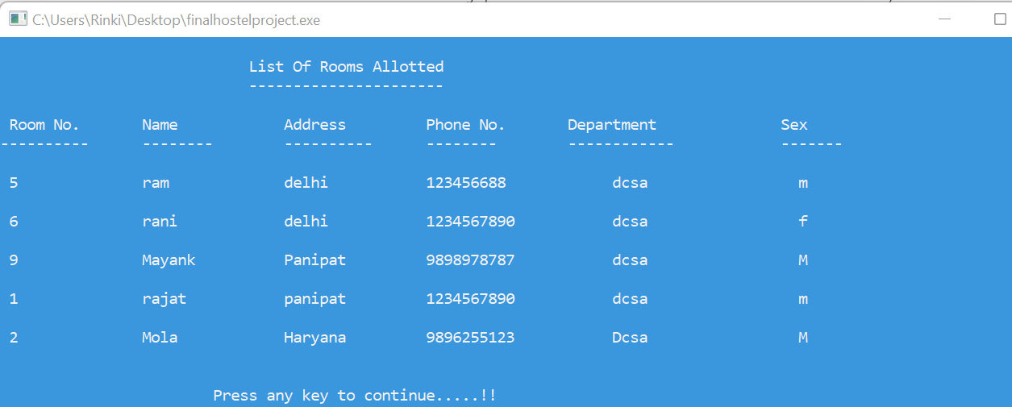

Information of all the room is displayed on the screen.

Now the fourth option is update record which is further having 3 options:

* MODIFY RECORD
* DELETE RECORD
* HOSTEL ROOM RENT

Modify record will alter the user information of a particular account. Delete option will delete a particular record, and the hostel room rent optionwill display the rent of that particular room. The output of this little part of modify account is as follows:

1. **CODE FOR OPTION 4**

void hostel::edit()

{

system("cls");

int choice,r;

cout<<"\n\t\t\t\t EDIT MENU";

cout<<"\n \t\t\t\t---------";

cout<<"\n\n\t\t\t\t 1.Modify Customer Record";

cout<<"\n\t\t\t\t 2.Delete Customer Record";

cout<<"\n\t\t\t\t 3. Hostel Room Rent";

cout<<"\n\t\t\t\t Enter your choice: ";

cin>>choice;

system("cls");

cout<<"\n\t\t\t\t\t Enter room no: " ;

cin>>r;

switch(choice)

{

case 1: modify(r);

break;

case 2: delete_rec(r);

break;

case 3: bill(r);

break;

default: cout<<"\n Wrong Choice.....!!";

}

cout<<"\n Press any key to continue....!!!";

getch();

}

**Output of this shown is as follows:**

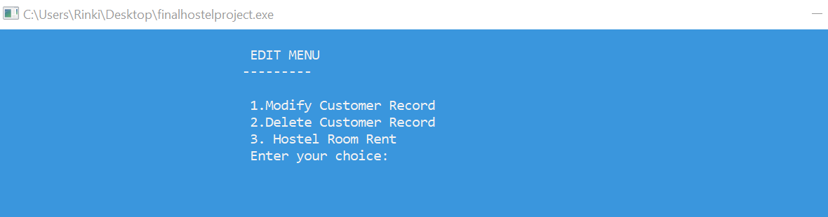

Option 4 has further 3 more option:

**Code for 4.1option**

void hostel::modify(int r)

{

system("Color 7f");

long pos,flag=0;

fstream file("Record.dat",ios::in|ios::out|ios::binary);

while(!file.eof())

{

pos=file.tellg();

file.read((char*)this,sizeof(hostel));

if(room_no==r)

{

cout<<"\n\t\t\t\t\t Enter New Details";

cout<<"\n\t\t\t\t\t-----------------";

cout<<"\n\n\t\t\t\t\t Name: ";

cin>>name;

cout<<"\n\t\t\t\t\t Address: ";

cin>>address;

again:

cout<<"\n\t\t\t\t\t Phone No:\t\t ";

cin>>phone;

if(strlen(phone)!=10)

{

cout<<"\n\t\t\t\t\t Requird 10 digits Phone Number:\n";

goto again;

}

cout<<"\n\t\t\t\t\t Dept Name:\t ";

cin>>dept;

again1:

cout<<"\n\t\t\t\t\t GENDER(M:male,F:female) : ";

cin>>sex;

if((sex!='m')&&(sex!='M')&&(sex!='F')&&(sex!='f'))

{

cout<<"\tWrong operation; give correct Info";

goto again1;

}

file.seekg(pos);

file.write((char*)this,sizeof(hostel));

cout<<"\n Record is modified....!!";

flag=1;

break;

}

}

if(flag==0)

cout<<"\n Sorry Room no. not found or vacant...!!";

file.close();

}

**Output of this shown is as follows:**

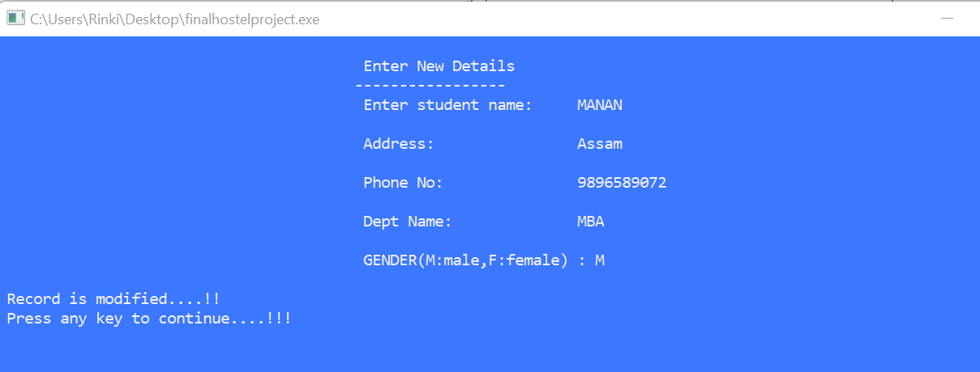

**Code for 4.2option**

void hostel::delete_rec(int r)

{

system("Color 7f");

int flag=0;

char ch;

ifstream fin("Record.dat",ios::in);

ofstream fout("temp.dat",ios::out);

while(!fin.eof())

{

fin.read((char*)this,sizeof(hostel));

if(room_no==r)

{

cout<<"\n\t\t\t\t Name: "<<name;

cout<<"\n\t\t\t\t Address: "<<address;

cout<<"\n\t\t\t\t Phone no: "<<phone;

cout<<"\n\t\t\t\t Department name: "<<dept;

cout<<"\n\t\t\t\t Gender: "<<sex;

cout<<"\n\n\t\t\t\t Do you want to delete this record(y/n): ";

cin>>ch;

if(ch=='n')

fout.write((char*)this,sizeof(hostel));

flag=1;

}

else

fout.write((char*)this,sizeof(hostel));

}

fin.close();

fout.close();

if(flag==0)

cout<<"\n ROOM IS VACANT YOU CAN APPLY FOR IT...!!";

else{

remove("Record.dat");

rename("temp.dat","Record.dat");

}

}

**Output of this shown is as follows:**

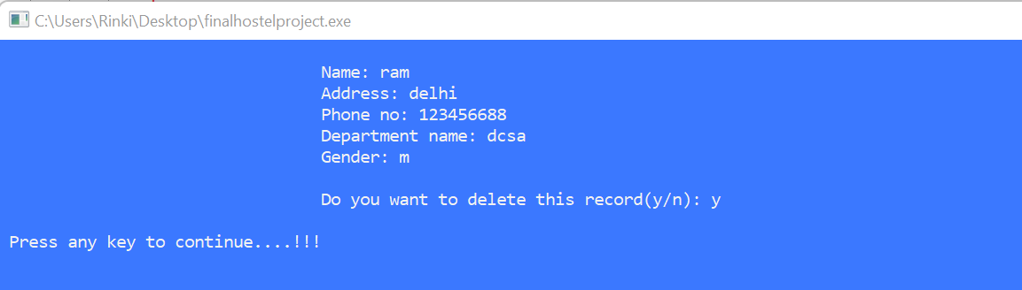

**Code for 4.3option**

void hostel::bill(int r)

{

system("COLOR 3f");

ifstream f1;

f1.open("Record.dat",ios::in|ios::binary);

if(!f1)

cout<<"cannot open";

else

{

f1.read((char*)this,sizeof (hostel));

while(f1)

{

f1.read((char*)this,sizeof(hostel));

}

if (room_no == r)

{

if(room_no>=1&&room_no<=17)

cout<<"\t\t\t\tYour room rent = 2000";

else if (room_no>=18&&room_no<=34)

cout<<"\t\t\t\tYour room rent = 5000" ;

else if (room_no>=35&&room_no<=51)

cout<<"\t\t\t\tYour room rent = 7000";

else

cout<<"\t\t\t\tYou enter wrong room no";

}

else

{

cout<<"room no. not found";}

}

f1.close();

getch();

}

**Output of this shown is as follows:**

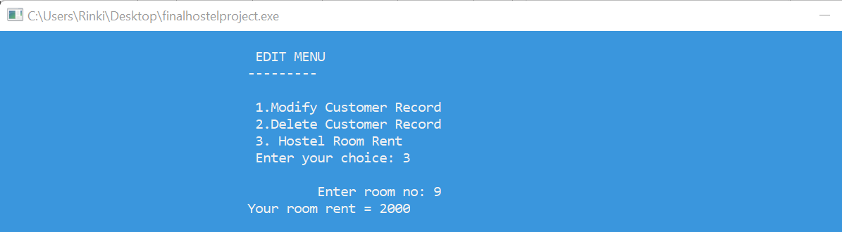

Now the fifth option tell us about the rules and regulation of the hostel.

1. **CODE FOR OPTION 5**

void hostel::info()

{

system("cls");

system("COLOR 3f");

cout<<"\n\t\t\t\t\t RULES AND REGULATIONS: "<<endl;

cout<<"\n\t\t\t\t\t ----------------------"<<endl<<endl,

cout<<"\n\t\t ~In Girls hostel 1 there is total 51 rooms ";

cout<<"\n\t\t~In the First floor there is 1-17 rooms which is normal

room with fan and having the rent \n\t\t 2000 per month. ";

cout<<"\n\t\t~In the Second floor there is 18-34 rooms which is normal

room with cooler and having the \n\t\t rent 5000 per month. ";

cout<<"\n\t\t~In the Third floor there is 35-51 rooms which is Ac room and having the rent 7000 per month. ";

cout<<"\n\t\t~In the Ground floor we are having the reception area, mess ,tuck shop, gym and canteen. ";

cout<<"\n\t\t~In the Ground floor we are also having the 1 warden romm";

cout<<"\n\t\t~HELPLINE NUMBER :01686-234123 ";

cout<<"\n\n Press any key to continue!!";

system("pause");

}

**Output of this shown is as follows:**

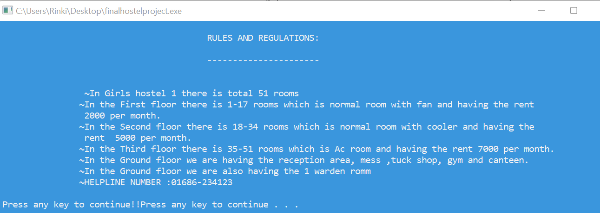

This option is used to close the file.

1. **CODE FOR OPTION 6**

Exit(0);

**Output of this shown is as follows:**

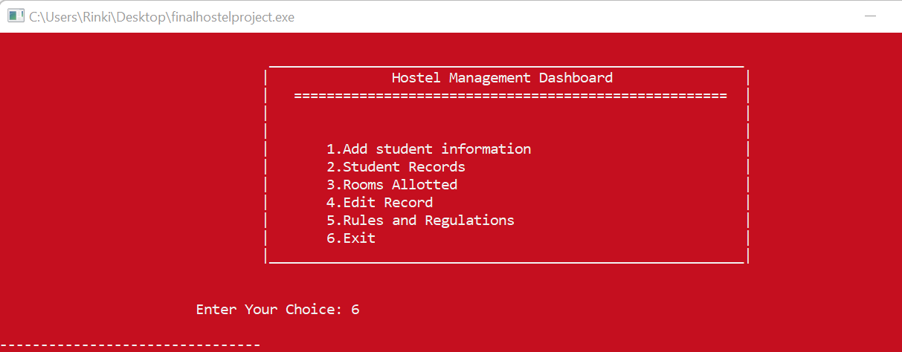

To recapitulate, these were the important options that were been part of the project “Hostel Management System”. The code has been included in this report in the form of some important subroutines. Before this implementation code few algorithms were developed and this was possibly the best algorithm out of them. I have tried to make the time complexity less as much as possible. During this implementation phase, the syntax was not an issue, this is because of the convenience of the simple syntax of C++ which has been studied in the class perfectly. A little problem arose when the in-built functions were having a wide range which were unknown to me being a beginner. But this problem was sorted by proper R&D (research and development). The line of code was another issue, this code is of about 900 lines, which has been quite difficult to handle. This issue has been considered as the limitation of C++ that the projects developed in this language has lengthy codes. Rest of the thing went pretty well. The graphics worked pretty fine and makes the project quite interesting. The files were handled easily and efficiently.

So, implementation phase was full of thrills and interests as far as the “Hostel Management System was concerned”.

# TESTING WITH VALIDATIONS

Software testing is defined as an activity to check whether the actual results match the expected results and to ensure that the software system is [Defect](https://www.guru99.com/defect-management-process.html) free. It involves execution of a software component or system component to evaluate one or more properties of interest. Software testing also helps to identify errors, gaps or missing requirements in contrary to the actual requirements. It can be either done manually or using automated tools. Some prefer saying Software testing as a [White Box](https://www.guru99.com/white-box-testing.html) and [Black Box Testing](https://www.guru99.com/black-box-testing.html). In simple terms, Software Testing means Verification of Application Under Test (AUT). For checking the project is running properly under different circumstances following **datasets** been supplied to the program:

* **Validation on password:** The password set for the admin login is “123”, if any other password is supplied as input then the code has been handled by printing the message “Wrong password” as shown in the following screen shot.

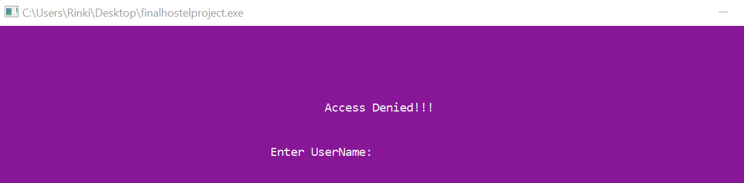

**Validation on Room Number:** In this it will firstly check whether the room is vacant or not. If the room is not vacant it will print the error that ”Room is no vacant”.

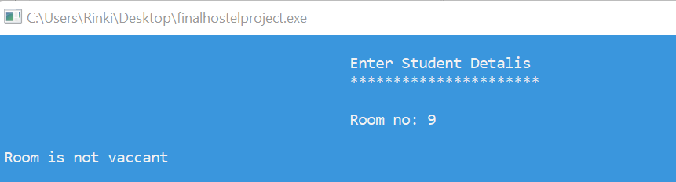

**Number of digits in Mobile number:** The number of digits of an Mobile Number is only be 10 digits, neither more nor less. If the number of digits in account number is more or less than 10, then the error has been handled by printing the message “10 digit required” as shown in the screen shot on the next page.

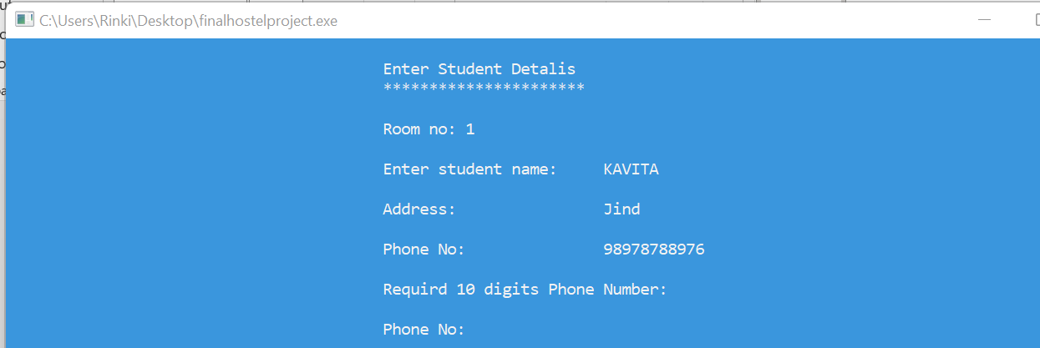

**Gender (male or female):** The gender of account holder can only be male or female. So when the gender of the person is asked the only options that are permissible are (m,M,f,F) where f and F means gender is female; M and m means gender is male. If any other character is typed then the message “Give correct info” is printed whose screen shot has been shown as follows:

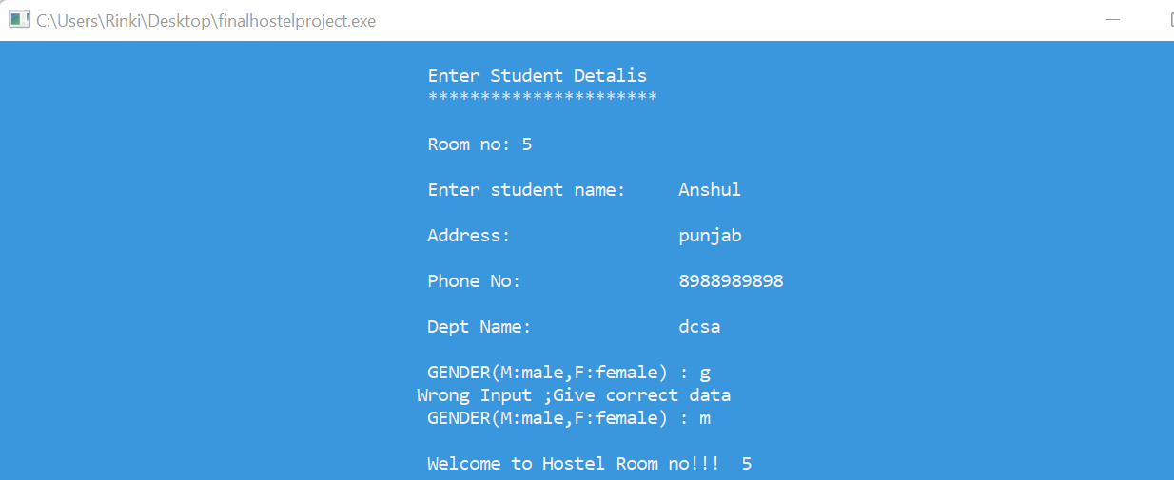

**Room is Filled or not:**

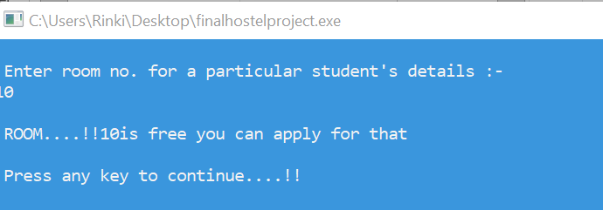

So these were some of the different datasets that were fed to the program during the testing phase. All the data sets have been handled in this project. This handling of datasets are called validations. Validations are required in every project to ensure the correctness of the data that is being supplied to the program.

So overall, the testing phase is one of the important step. Without testing no errors can be removed (if any) from the code. In this project as well, all the validations were applied as the result of the testing done. Before testing, the validations were not applied and the components were not working properly. But it was possible due to testing that all the errors occurred in the program were handled efficiently

# SIGNIFICANCE OF THE PROJECT

Now that the project has been developed, it should have some significance. Any project that has been developed would be having some purpose. Significance will tell, how the project would be beneficial for people of different application areas. As far as application areas are concerned, there is a wide range. Out of them, let us select the most popular application areas to understand the significance of the project. The significance of the project will be demonstrated in the following application areas:

* **Manage Room Details**

Hostel plugin in school ERP also involves recording all the details about the hostel rooms. This includes details like the number of rooms in each hostel, and the number of students each room can accommodate. For each room, the online software allows the administration team to assign a fare that students will need to pay.

* **Allocate Room to students**

Room allotment is an essential part of hostel management. Students can be provided hostel accommodation based on the availability of rooms. Manual allocation of rooms can be very difficult in large to medium sized hostels and an online system makes this task easier and error free.

**Future Enhancement**

Hostel management system (HMS).This hostel management software is designed for people who want to manage various activities in the hostel.

This project is designed to fulfill the need of the future generations.

This project is small package which includes different categories as well as having all possible features. We have expected that it will be helpful to the, customers as well as Administrative member.

We will improve this project in future with online room reservation system and also improve in security by providing a magnetic coated card to permanent students for automatic check in and check out.

**Conclusion**

This project made by the handwork of me and is a small effort in the development of larger programs, and it involves limited aspects which are needed in day to day hostel operation.

The software development although is a very difficult task but it can be carried out successfully with the effort of my work. After the completion of this

project we learnt different things about software and its development.

Thus this project can be a guideline for the beginners and can be example for the development of a small program

# BIBLIOGRAPHY/ REFERENCES

* **Let us C++** by ‘Yashavant P. Kanetkar’
* **Learn programming in C++** by ‘Anshuman Sharma’
* <https://www.tutorialspoint.com/cplusplus/index.htm>
* <https://www.w3schools.com/cpp/>
* <https://www.geeksforgeeks.org/cpp-tutorial/>
* <https://beginnersbook.com/2017/08/c-plus-plus-tutorial-for-beginners/>